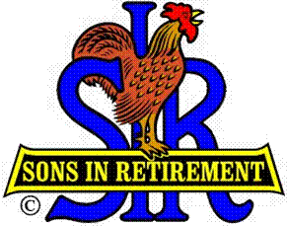

Las Trampas Branch 116

Executive Committee Meeting Agenda

July 17, 2017

9:30 AM
- Call Meeting to Order and confirm we have a quorum.
- Review Agenda/Minutes for Changes/Additions.
- Standing Reports:
Secretary – Fred Schafer – Approval of June 19, 2017 minutes.
Attendance – Sam Beret
Head count, missed luncheon receipts.
Membership – Phil Goff
New Members to be inducted:
Guests Today:
Visitors:

- Budget – Jim Nickles

- Big Sir Report:
- Storyteller: Andy Benz
- Chaplain: Michael Barrington
- Neil Schmidt – “New Branch Website”
- Phil Goff – Guest Speaker Selection Process
- Letter to Absentee Members – Responses
- 2018 Open Positions – Sam Beret (Attendance) and Pat Bermingham (Greeter).

- Little Sir Report:
- July Speaker(s) – Ted Clements & Debra Tolwhite – “Save Mt. Diablo”.
- July Speaker – David Ainsworth – SS Jeremiah O’Brian.
- Volunteer golf after luncheons.
- Other

- Other Reports

- Adjourn – 10:15 am

